**A Project Report**

**ON**

**Movie Booking System**

**For**

**The realization of the movie ticket**

**Submitted by**

**Team name:Flying**

**崔子兰(Spring)(R8J9400055)**

**周鹏(Tony)(R8J9400063)**

**郝梓彤(Colson)(R8J9400041)**

**May 6, 2019 to May 23, 2019**

**School of computer and cyberspace security**

**Hainan university**



**一．Index of the project**

|  |  |
| --- | --- |
| **details** | Page no. |
| Team description and overview | 2 |
| Software Requirements | 2~3 |
| System development background | 3~4 |
| Database design | 4 |
| The system design | 4~5 |
| 1.System overall structure design | 4 |
| 2.Module function design | 5 |
| 3.The conceptual design | 5 |
| 4.External design | 5 |
| Cost estimation | 5~6 |
| Code | 6~64 |

**二．Team description and overview**

Our group is composed of three students from class 6, class 2018 software engineering, school of computer and network space security, hainan university.  
 Members include：Spring，Tony，Colson  
 Our reproduction team is not only in the front end of technology, we pay more attention to the customer's product expression is clear and accurate, so we can better express the customer's intention, and constantly meet the customer's demand for film reservation service.  
 Team philosophy: the company adheres to the principle of integrity, standardization and efficiency, wins the market with technology, gains credibility with creative services, and wholeheartedly provides quality, efficient and efficient services for our customers.Face the future and adhere to independent innovation.

1. **Software Requirements**

IDEA 2019-1-2

NetBeans IDE 8.0.2

**四．System development background**

With the rapid development of the national economy, people have higher and higher requirements on life, service speed and convenience. They have higher requirements on the construction and management of the cinema industry.In order to adapt to and promote the development of film industry, movie theater companies and departments began to widespread adoption of computer management system, online ticket reservation service, greatly reduce the labor intensity of the management staff, improve the efficiency of the various departments, improve the service level of the center city, and gradually set up the enterprise image.

This paper uses Java language and MySQL tools to write the system.This topic adopts the modular design concept, the booking system is divided into the foreground function module and the background management module, the foreground function module to achieve user registration and registration and booking business, the background management module to achieve video management, ticket management and user management and other functions.This topic is the final display is a complete front desk ticket interface and background management interface, to achieve all the functions of the design objectives.

**五．Database design**

|  |  |  |  |  |
| --- | --- | --- | --- | --- |
| USER_LOGIN | | | | |
| **Field Name** | **Data Type** | **Size** | **Primary Key** | **Null** |
| ID | Int |  | Y | N |
| un | varchar | 12 |  |  |
| pw1 | varchar | 20 |  |  |
| unyear | int | 4 |  |  |
| unmonth | int | 2 |  |  |
| unday | int | 2 |  |  |
| Age | int |  |  |  |
| Email | varchar | 20 |  |  |
| Country | varchar | 20 |  |  |
| Adress | varchar | 30 |  |  |
| Tellphone | varchar | 11 |  |  |

**六．The system design**

**1.System overall structure design**

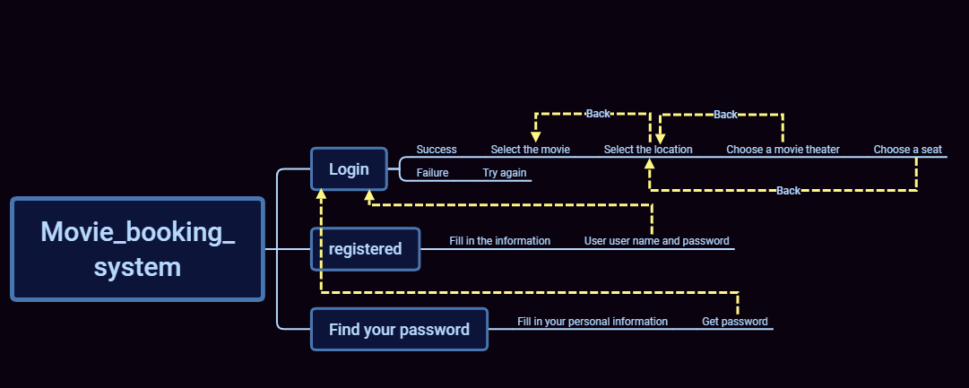

**2.Module function design**

Our program implements the user's login, registration, and password recovery functions. The user can reserve the appropriate location by selecting the movie, location, and movie theater he wants to watch.

**3.The conceptual design**

With a simple click, the user can easily book the movie ticket they want according to the project guidelines.

**4.External design**

We use some cute, fresh picture to make the background, in order to give the user a happy mood, when they choose the movie.

七．**Cost estimation**

Today, software is the most expensive element of virtually a computer - based systems. So it necessary to estimate cost of project for a developer, because large cost estimation error can make the difference between profit and loss. Cost overrun can be disastrous for the developer.

Software cost and effort estimation will never be an exact science. Too many variables- human, technical environment,-can affect the ultimate cost of software and effort applied to develop the software.

For cost estimation of this project (RBRS), I carry out the different tasks in this project according to the time period gives below. First we estimate the cost in working hours.

|  |  |  |  |
| --- | --- | --- | --- |
| Team member | Work task | Starting date | Ending date |
| Spring | Java,document,PPT | 2019/5/6 | 2019/5/23 |
| Tony | MySQL,document | 2019/5/6 | 2019/5/23 |
| Colson | Java,document | 2019/5/6 | 2019/5/23 |

**Code of Login**

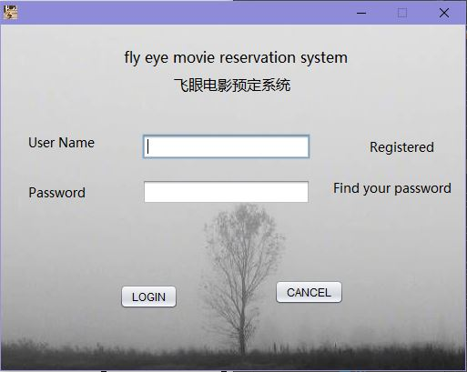

package com.all;

import java.awt.*;

import java.awt.event.*;

import java.sql.Connection;

import java.sql.DriverManager;

import java.sql.PreparedStatement;

import java.sql.ResultSet;

import javax.swing.*;

/*

* Created by JFormDesigner on Mon May 06 17:56:51 CST 2019

*/

/**

* @author Spring

*/

public class Registered_login extends JFrame {

public Registered_login() {

initComponents();

}

private void loginMouseClicked(MouseEvent e) {

PreparedStatement pst;

ResultSet rs=null;

try {

Class.forName("com.mysql.jdbc.Driver");

Connection con = DriverManager.getConnection("jdbc:mysql://localhost:3306/LoginDB", "root", "1234");

String sql = "select * from users where un=? and pw1=?";

pst = con.prepareStatement(sql);

pst.setString(1, t1.getText());

pst.setString(2, new String(p1.getPassword()));

rs = pst.executeQuery();

if (t1.getText().length() == 0) {

JOptionPane.showMessageDialog(this, "Empty User Name", "Warning", JOptionPane.WARNING_MESSAGE);

} else if (p1.getPassword().length == 0) {

JOptionPane.showMessageDialog(this, "Empty Password", "Warning", JOptionPane.WARNING_MESSAGE);

} else if (rs.next()) {

Show s = new Show();

s.setVisible(true);

dispose();

} else {

JOptionPane.showMessageDialog(this, "Incorrect User Name or Password", "Error", JOptionPane.ERROR_MESSAGE);

}

} catch (Exception c) {

JOptionPane.showMessageDialog(this, c);

}

}

private void registeredMouseClicked(MouseEvent e) {

new RegisteredForm().setVisible(true);

}

private void cancelMouseClicked(MouseEvent e) {

this.dispose();

}

private void findpwMouseClicked(MouseEvent e) {

new Find().setVisible(true);

}

private void initComponents() {

// JFormDesigner - Component initialization - DO NOT MODIFY //GEN-BEGIN:initComponents

panel1 = new JPanel();

label1 = new JLabel();

label2 = new JLabel();

label3 = new JLabel();

label4 = new JLabel();

t1 = new JTextField();

label5 = new JLabel();

label6 = new JLabel();

button1 = new JButton();

cancel = new JButton();

p1 = new JPasswordField();

label7 = new JLabel();

//======== this ========

setIconImage(new ImageIcon(getClass().getResource("/Pictures/hand.jpg")).getImage());

setResizable(false);

Container contentPane = getContentPane();

contentPane.setLayout(new BoxLayout(contentPane, BoxLayout.X_AXIS));

//======== panel1 ========

{

panel1.setLayout(null);

//---- label1 ----

label1.setText("fly eye movie reservation system");

label1.setFont(new Font("Microsoft YaHei UI", Font.PLAIN, 16));

panel1.add(label1);

label1.setBounds(135, 25, 250, label1.getPreferredSize().height);

//---- label2 ----

label2.setText("\u98de\u773c\u7535\u5f71\u9884\u5b9a\u7cfb\u7edf");

label2.setFont(new Font("Microsoft YaHei UI", Font.PLAIN, 16));

panel1.add(label2);

label2.setBounds(190, 55, 130, 22);

//---- label3 ----

label3.setText("User Name");

label3.setFont(new Font("Microsoft YaHei UI", Font.PLAIN, 14));

panel1.add(label3);

label3.setBounds(30, 120, 83, label3.getPreferredSize().height);

//---- label4 ----

label4.setText("Password");

label4.setFont(new Font("Microsoft YaHei UI", Font.PLAIN, 14));

panel1.add(label4);

label4.setBounds(30, 175, 83, label4.getPreferredSize().height);

panel1.add(t1);

t1.setBounds(155, 120, 185, t1.getPreferredSize().height);

//---- label5 ----

label5.setText("Registered");

label5.setFont(new Font("Microsoft YaHei UI", Font.PLAIN, 14));

label5.addMouseListener(new MouseAdapter() {

@Override

public void mouseClicked(MouseEvent e) {

registeredMouseClicked(e);

}

});

panel1.add(label5);

label5.setBounds(405, 125, 83, 19);

//---- label6 ----

label6.setText("Find your password");

label6.setFont(new Font("Microsoft YaHei UI", Font.PLAIN, 14));

label6.addMouseListener(new MouseAdapter() {

@Override

public void mouseClicked(MouseEvent e) {

findpwMouseClicked(e);

}

});

panel1.add(label6);

label6.setBounds(365, 170, 130, 19);

//---- button1 ----

button1.setText("LOGIN");

button1.addMouseListener(new MouseAdapter() {

@Override

public void mouseClicked(MouseEvent e) {

loginMouseClicked(e);

}

});

panel1.add(button1);

button1.setBounds(new Rectangle(new Point(130, 285), button1.getPreferredSize()));

//---- cancel ----

cancel.setText("CANCEL");

cancel.addMouseListener(new MouseAdapter() {

@Override

public void mouseClicked(MouseEvent e) {

cancelMouseClicked(e);

}

});

panel1.add(cancel);

cancel.setBounds(new Rectangle(new Point(300, 280), cancel.getPreferredSize()));

panel1.add(p1);

p1.setBounds(155, 170, 185, p1.getPreferredSize().height);

//---- label7 ----

label7.setIcon(new ImageIcon(getClass().getResource("/Pictures/8.jpg")));

panel1.add(label7);

label7.setBounds(-75, -10, 585, 390);

{ // compute preferred size

Dimension preferredSize = new Dimension();

for(int i = 0; i < panel1.getComponentCount(); i++) {

Rectangle bounds = panel1.getComponent(i).getBounds();

preferredSize.width = Math.max(bounds.x + bounds.width, preferredSize.width);

preferredSize.height = Math.max(bounds.y + bounds.height, preferredSize.height);

}

Insets insets = panel1.getInsets();

preferredSize.width += insets.right;

preferredSize.height += insets.bottom;

panel1.setMinimumSize(preferredSize);

panel1.setPreferredSize(preferredSize);

}

}

contentPane.add(panel1);

pack();

setLocationRelativeTo(getOwner());

// JFormDesigner - End of component initialization //GEN-END:initComponents

}

public static void main(String args[]) {

try {

for (javax.swing.UIManager.LookAndFeelInfo info : javax.swing.UIManager.getInstalledLookAndFeels()) {

if ("Nimbus".equals(info.getName())) {

javax.swing.UIManager.setLookAndFeel(info.getClassName());

break;

}

}

} catch (ClassNotFoundException ex) {

java.util.logging.Logger.getLogger(Registered_login.class.getName()).log(java.util.logging.Level.SEVERE, null, ex);

} catch (InstantiationException ex) {

java.util.logging.Logger.getLogger(Registered_login.class.getName()).log(java.util.logging.Level.SEVERE, null, ex);

} catch (IllegalAccessException ex) {

java.util.logging.Logger.getLogger(Registered_login.class.getName()).log(java.util.logging.Level.SEVERE, null, ex);

} catch (javax.swing.UnsupportedLookAndFeelException ex) {

java.util.logging.Logger.getLogger(Registered_login.class.getName()).log(java.util.logging.Level.SEVERE, null, ex);

}

//</editor-fold>

/* Create and display the form */

java.awt.EventQueue.invokeLater(new Runnable() {

public void run() {

Registered_login relogin = new Registered_login();

relogin.setLocationRelativeTo(null);

relogin.setVisible(true);

}

});

}

// JFormDesigner - Variables declaration - DO NOT MODIFY //GEN-BEGIN:variables

private JPanel panel1;

private JLabel label1;

private JLabel label2;

private JLabel label3;

private JLabel label4;

private JTextField t1;

private JLabel label5;

private JLabel label6;

private JButton button1;

private JButton cancel;

private JPasswordField p1;

private JLabel label7;

// JFormDesigner - End of variables declaration //GEN-END:variables

}

**Code of Registered**

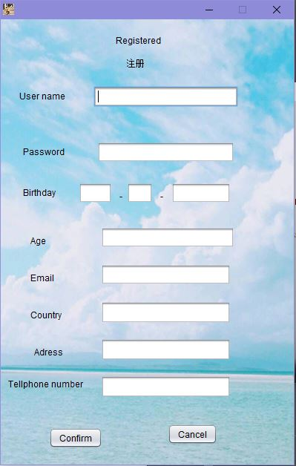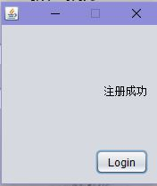

package com.all;

import com.company.connectSQL;

import java.awt.*;

import java.awt.event.*;

import java.sql.Connection;

import java.sql.PreparedStatement;

import java.sql.ResultSet;

import java.sql.SQLException;

import javax.swing.*;

import javax.xml.transform.Result;

/**

* @author Spring

*/

public class RegisteredForm extends JFrame {

private Object JPasswordField;

public RegisteredForm() {

initComponents();

}

private void confirmMouseClicked(MouseEvent e) {

if (username.getText().length() == 0) {

JOptionPane.showMessageDialog(this, "Username can not be empty!", "Warning message", JOptionPane.WARNING_MESSAGE);

return;

}

if (passwordField1.getPassword().length == 0) {

JOptionPane.showMessageDialog(this, "Password can not be empty!", "Warning message", JOptionPane.WARNING_MESSAGE);

return;

}

String IDsql = "select ID from users order by ID desc limit 1;";

String sql = "insert into users value (?,?,?,?,?,?,?,?,?,?,?);";

int ID = 0;

Connection CONN = new connectSQL().conSql();

PreparedStatement PST = null;

ResultSet RS = null;

try {

PST = CONN.prepareStatement(IDsql);

RS = PST.executeQuery();

if(RS.next()){

ID = RS.getInt(1) + 1;

}

PST = CONN.prepareStatement(sql);

PST.setInt(1,ID);

PST.setString(2,username.getText());

PST.setString(3,new String(passwordField1.getPassword()));

PST.setInt(4,Integer.valueOf(unyear.getText()));

PST.setInt(5,Integer.valueOf(unmonth.getText()));

PST.setInt(6,Integer.valueOf(unday.getText()));

PST.setInt(7,Integer.valueOf(unage.getText()));

PST.setString(8,email.getText());

PST.setString(9,contry.getText());

PST.setString(10,adress.getText());

PST.setString(11,tellphone.getText());

int n = PST.executeUpdate();

if(n > 0){

Win w = new Win();

w.setVisible(true);

dispose();

}else {

Loss l = new Loss();

l.setVisible(true);

dispose();

}

} catch (SQLException e1) {

e1.printStackTrace();

}

}

private void cancelMouseClicked(MouseEvent e) {

this.dispose();

}

private void initComponents() {

// JFormDesigner - Component initialization - DO NOT MODIFY //GEN-BEGIN:initComponents

label1 = new JLabel();

label2 = new JLabel();

label3 = new JLabel();

label4 = new JLabel();

label6 = new JLabel();

label7 = new JLabel();

label8 = new JLabel();

label9 = new JLabel();

label10 = new JLabel();

label11 = new JLabel();

username = new JTextField();

passwordField1 = new JPasswordField();

unyear = new JTextField();

label12 = new JLabel();

label13 = new JLabel();

unmonth = new JTextField();

unday = new JTextField();

unage = new JTextField();

email = new JTextField();

contry = new JTextField();

adress = new JTextField();

tellphone = new JTextField();

confirm = new JButton();

cancel = new JButton();

label14 = new JLabel();

//======== this ========

setIconImage(new ImageIcon(getClass().getResource("/Pictures/hand.jpg")).getImage());

setResizable(false);

Container contentPane = getContentPane();

contentPane.setLayout(null);

//---- label1 ----

label1.setText("Registered");

contentPane.add(label1);

label1.setBounds(new Rectangle(new Point(155, 20), label1.getPreferredSize()));

//---- label2 ----

label2.setText("\u6ce8\u518c");

contentPane.add(label2);

label2.setBounds(new Rectangle(new Point(170, 50), label2.getPreferredSize()));

//---- label3 ----

label3.setText("User name");

contentPane.add(label3);

label3.setBounds(new Rectangle(new Point(25, 95), label3.getPreferredSize()));

//---- label4 ----

label4.setText("Password");

contentPane.add(label4);

label4.setBounds(new Rectangle(new Point(30, 170), label4.getPreferredSize()));

//---- label6 ----

label6.setText("Birthday");

contentPane.add(label6);

label6.setBounds(new Rectangle(new Point(30, 225), label6.getPreferredSize()));

//---- label7 ----

label7.setText("Age");

contentPane.add(label7);

label7.setBounds(new Rectangle(new Point(40, 290), label7.getPreferredSize()));

//---- label8 ----

label8.setText("Email");

contentPane.add(label8);

label8.setBounds(new Rectangle(new Point(40, 340), label8.getPreferredSize()));

//---- label9 ----

label9.setText("Adress");

contentPane.add(label9);

label9.setBounds(new Rectangle(new Point(45, 440), label9.getPreferredSize()));

//---- label10 ----

label10.setText("Country");

contentPane.add(label10);

label10.setBounds(new Rectangle(new Point(40, 390), label10.getPreferredSize()));

//---- label11 ----

label11.setText("Tellphone number");

contentPane.add(label11);

label11.setBounds(10, 480, label11.getPreferredSize().width, 22);

contentPane.add(username);

username.setBounds(125, 90, 195, username.getPreferredSize().height);

contentPane.add(passwordField1);

passwordField1.setBounds(130, 165, 185, passwordField1.getPreferredSize().height);

contentPane.add(unyear);

unyear.setBounds(105, 220, 45, unyear.getPreferredSize().height);

//---- label12 ----

label12.setText("-");

contentPane.add(label12);

label12.setBounds(160, 230, 20, label12.getPreferredSize().height);

//---- label13 ----

label13.setText("-");

contentPane.add(label13);

label13.setBounds(215, 230, 20, 17);

contentPane.add(unmonth);

unmonth.setBounds(170, 220, 35, unmonth.getPreferredSize().height);

contentPane.add(unday);

unday.setBounds(230, 220, 80, unday.getPreferredSize().height);

contentPane.add(unage);

unage.setBounds(135, 280, 180, unage.getPreferredSize().height);

contentPane.add(email);

email.setBounds(135, 330, 175, email.getPreferredSize().height);

contentPane.add(contry);

contry.setBounds(135, 380, 175, 30);

contentPane.add(adress);

adress.setBounds(135, 430, 175, 30);

contentPane.add(tellphone);

tellphone.setBounds(135, 480, 175, 30);

//---- confirm ----

confirm.setText("Confirm");

confirm.addMouseListener(new MouseAdapter() {

@Override

public void mouseClicked(MouseEvent e) {

confirmMouseClicked(e);

}

});

contentPane.add(confirm);

confirm.setBounds(new Rectangle(new Point(65, 550), confirm.getPreferredSize()));

//---- cancel ----

cancel.setText("Cancel");

cancel.addMouseListener(new MouseAdapter() {

@Override

public void mouseClicked(MouseEvent e) {

cancelMouseClicked(e);

}

});

contentPane.add(cancel);

cancel.setBounds(new Rectangle(new Point(225, 545), cancel.getPreferredSize()));

//---- label14 ----

label14.setIcon(new ImageIcon(getClass().getResource("/Pictures/9.png")));

contentPane.add(label14);

label14.setBounds(new Rectangle(new Point(-5, 0), label14.getPreferredSize()));

{ // compute preferred size

Dimension preferredSize = new Dimension();

for(int i = 0; i < contentPane.getComponentCount(); i++) {

Rectangle bounds = contentPane.getComponent(i).getBounds();

preferredSize.width = Math.max(bounds.x + bounds.width, preferredSize.width);

preferredSize.height = Math.max(bounds.y + bounds.height, preferredSize.height);

}

Insets insets = contentPane.getInsets();

preferredSize.width += insets.right;

preferredSize.height += insets.bottom;

contentPane.setMinimumSize(preferredSize);

contentPane.setPreferredSize(preferredSize);

}

pack();

setLocationRelativeTo(getOwner());

// JFormDesigner - End of component initialization //GEN-END:initComponents

}

// JFormDesigner - Variables declaration - DO NOT MODIFY //GEN-BEGIN:variables

private JLabel label1;

private JLabel label2;

private JLabel label3;

private JLabel label4;

private JLabel label6;

private JLabel label7;

private JLabel label8;

private JLabel label9;

private JLabel label10;

private JLabel label11;

private JTextField username;

private JPasswordField passwordField1;

private JTextField unyear;

private JLabel label12;

private JLabel label13;

private JTextField unmonth;

private JTextField unday;

private JTextField unage;

private JTextField email;

private JTextField contry;

private JTextField adress;

private JTextField tellphone;

private JButton confirm;

private JButton cancel;

private JLabel label14;

// JFormDesigner - End of variables declaration //GEN-END:variables

}

**Code of Find password**

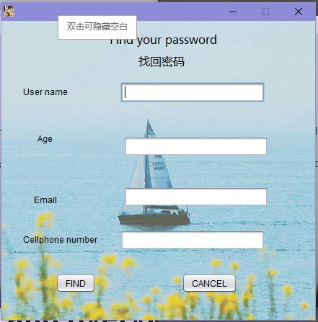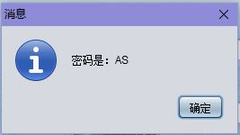

package com.all;

import com.company.connectSQL;

import java.awt.*;

import java.awt.event.*;

import java.sql.Connection;

import java.sql.PreparedStatement;

import java.sql.ResultSet;

import java.sql.SQLException;

import javax.swing.*;

/**

* @author Spring

*/

public class Find extends JFrame {

public Find() {

initComponents();

}

private void button2MouseClicked(MouseEvent e) {

this.dispose();

}

private void button1MouseClicked(MouseEvent e) {

String sql = "select pw1 from users where un = ? and Age = ? and Email = ? and Tellphone = ?;";

Connection CONN = new connectSQL().conSql();

ResultSet RS = null;

try {

PreparedStatement PST = CONN.prepareStatement(sql);

PST.setString(1,Un.getText());

PST.setInt(2,Integer.valueOf(age.getText()));

PST.setString(3,Email.getText());

PST.setString(4,callnum.getText());

RS = PST.executeQuery();

if(RS.next()){

JOptionPane.showMessageDialog(null,"密码是：" + RS.getString(1));

}

} catch (SQLException e1) {

e1.printStackTrace();

}

}

private void initComponents() {

// JFormDesigner - Component initialization - DO NOT MODIFY //GEN-BEGIN:initComponents

label1 = new JLabel();

label2 = new JLabel();

label3 = new JLabel();

label4 = new JLabel();

Un = new JTextField();

age = new JTextField();

button1 = new JButton();

label6 = new JLabel();

Email = new JTextField();

label7 = new JLabel();

callnum = new JTextField();

button2 = new JButton();

label8 = new JLabel();

//======== this ========

setIconImage(new ImageIcon(getClass().getResource("/Pictures/hand.jpg")).getImage());

setResizable(false);

Container contentPane = getContentPane();

contentPane.setLayout(null);

//---- label1 ----

label1.setText("Find your password");

label1.setFont(new Font("Microsoft YaHei UI", Font.PLAIN, 16));

contentPane.add(label1);

label1.setBounds(new Rectangle(new Point(150, 15), label1.getPreferredSize()));

//---- label2 ----

label2.setText("\u627e\u56de\u5bc6\u7801");

label2.setFont(new Font("Microsoft YaHei UI", Font.PLAIN, 16));

contentPane.add(label2);

label2.setBounds(190, 45, 65, 22);

//---- label3 ----

label3.setText("User name");

contentPane.add(label3);

label3.setBounds(new Rectangle(new Point(30, 90), label3.getPreferredSize()));

//---- label4 ----

label4.setText("Cellphone number");

contentPane.add(label4);

label4.setBounds(new Rectangle(new Point(30, 295), label4.getPreferredSize()));

contentPane.add(Un);

Un.setBounds(165, 85, 200, Un.getPreferredSize().height);

contentPane.add(age);

age.setBounds(170, 160, 200, age.getPreferredSize().height);

//---- button1 ----

button1.setText("FIND");

button1.addMouseListener(new MouseAdapter() {

@Override

public void mouseClicked(MouseEvent e) {

button1MouseClicked(e);

}

});

contentPane.add(button1);

button1.setBounds(new Rectangle(new Point(75, 350), button1.getPreferredSize()));

//---- label6 ----

label6.setText("Email");

contentPane.add(label6);

label6.setBounds(new Rectangle(new Point(45, 240), label6.getPreferredSize()));

contentPane.add(Email);

Email.setBounds(170, 230, 200, Email.getPreferredSize().height);

//---- label7 ----

label7.setText("Age");

contentPane.add(label7);

label7.setBounds(new Rectangle(new Point(50, 155), label7.getPreferredSize()));

contentPane.add(callnum);

callnum.setBounds(165, 290, 200, callnum.getPreferredSize().height);

//---- button2 ----

button2.setText("CANCEL");

button2.addMouseListener(new MouseAdapter() {

@Override

public void mouseClicked(MouseEvent e) {

button2MouseClicked(e);

}

});

contentPane.add(button2);

button2.setBounds(new Rectangle(new Point(250, 350), button2.getPreferredSize()));

//---- label8 ----

label8.setText("text");

label8.setIcon(new ImageIcon(getClass().getResource("/Pictures/10.png")));

contentPane.add(label8);

label8.setBounds(0, 0, 435, 415);

{ // compute preferred size

Dimension preferredSize = new Dimension();

for(int i = 0; i < contentPane.getComponentCount(); i++) {

Rectangle bounds = contentPane.getComponent(i).getBounds();

preferredSize.width = Math.max(bounds.x + bounds.width, preferredSize.width);

preferredSize.height = Math.max(bounds.y + bounds.height, preferredSize.height);

}

Insets insets = contentPane.getInsets();

preferredSize.width += insets.right;

preferredSize.height += insets.bottom;

contentPane.setMinimumSize(preferredSize);

contentPane.setPreferredSize(preferredSize);

}

pack();

setLocationRelativeTo(getOwner());

// JFormDesigner - End of component initialization //GEN-END:initComponents

}

// JFormDesigner - Variables declaration - DO NOT MODIFY //GEN-BEGIN:variables

private JLabel label1;

private JLabel label2;

private JLabel label3;

private JLabel label4;

private JTextField Un;

private JTextField age;

private JButton button1;

private JLabel label6;

private JTextField Email;

private JLabel label7;

private JTextField callnum;

private JButton button2;

private JLabel label8;

// JFormDesigner - End of variables declaration //GEN-END:variables

}

**Code of Chose a movie**

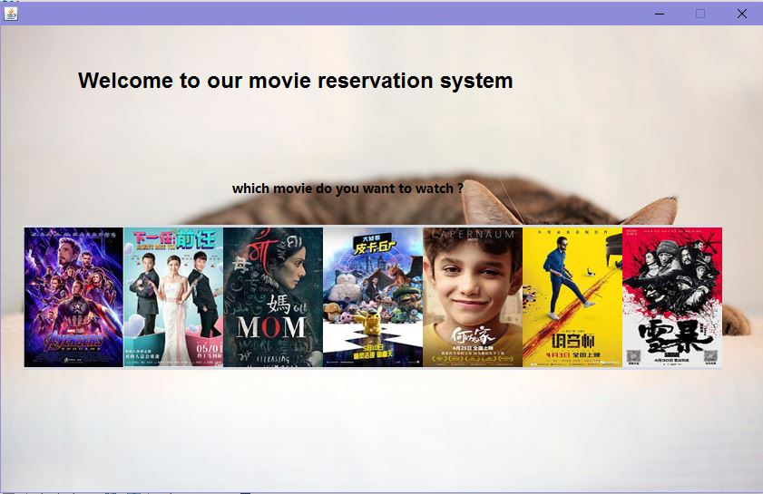

package com.all;

import java.awt.*;

import java.awt.event.*;

import javax.swing.*;

/**

* @author Spring

*/

public class Show extends JFrame {

public Show() {

initComponents();

}

private void picture1MouseClicked(MouseEvent e) {

Location l = new Location();

l.setVisible(true);

dispose();

}

private void picture2MouseClicked(MouseEvent e) {

Location l = new Location();

l.setVisible(true);

dispose();

}

private void picture3MouseClicked(MouseEvent e) {

Location l = new Location();

l.setVisible(true);

dispose();

}

private void picture4MouseClicked(MouseEvent e) {

Location l = new Location();

l.setVisible(true);

dispose();

}

private void picture5MouseClicked(MouseEvent e) {

Location l = new Location();

l.setVisible(true);

dispose();

}

private void picture6MouseClicked(MouseEvent e) {

Location l = new Location();

l.setVisible(true);

dispose();

}

private void picture7MouseClicked(MouseEvent e) {

Location l = new Location();

l.setVisible(true);

dispose();

}

private void initComponents() {

// JFormDesigner - Component initialization - DO NOT MODIFY //GEN-BEGIN:initComponents

panel1 = new JPanel();

picture1 = new JLabel();

picture2 = new JLabel();

picture3 = new JLabel();

picture4 = new JLabel();

picture5 = new JLabel();

picture6 = new JLabel();

picture7 = new JLabel();

label6 = new JLabel();

label1 = new JLabel();

label2 = new JLabel();

//======== this ========

setResizable(false);

Container contentPane = getContentPane();

contentPane.setLayout(null);

//======== panel1 ========

{

panel1.setLayout(new BoxLayout(panel1, BoxLayout.X_AXIS));

//---- picture1 ----

picture1.setIcon(new ImageIcon(getClass().getResource("/Pictures/\u590d\u4ec7\u8005\u8054\u76df41_1.jpg")));

picture1.addMouseListener(new MouseAdapter() {

@Override

public void mouseClicked(MouseEvent e) {

picture1MouseClicked(e);

}

});

panel1.add(picture1);

//---- picture2 ----

picture2.setIcon(new ImageIcon(getClass().getResource("/Pictures/\u4e0b\u4e00\u4efb\uff1a\u524d\u4efb1_1.jpg")));

picture2.addMouseListener(new MouseAdapter() {

@Override

public void mouseClicked(MouseEvent e) {

picture2MouseClicked(e);

}

});

panel1.add(picture2);

//---- picture3 ----

picture3.setIcon(new ImageIcon(getClass().getResource("/Pictures/a mom\u2019s1_1.jpg")));

picture3.addMouseListener(new MouseAdapter() {

@Override

public void mouseClicked(MouseEvent e) {

picture3MouseClicked(e);

}

});

panel1.add(picture3);

//---- picture4 ----

picture4.setIcon(new ImageIcon(getClass().getResource("/Pictures/\u5927\u4fa6\u63a2\u76ae\u5361\u4e181_1.jpg")));

picture4.addMouseListener(new MouseAdapter() {

@Override

public void mouseClicked(MouseEvent e) {

picture4MouseClicked(e);

}

});

panel1.add(picture4);

//---- picture5 ----

picture5.setIcon(new ImageIcon(getClass().getResource("/Pictures/\u4f55\u4ee5\u4e3a\u5bb61_1.jpg")));

picture5.addMouseListener(new MouseAdapter() {

@Override

public void mouseClicked(MouseEvent e) {

picture5MouseClicked(e);

}

});

panel1.add(picture5);

//---- picture6 ----

picture6.setIcon(new ImageIcon(getClass().getResource("/Pictures/\u8c03\u97f3\u5e081_1.jpg")));

picture6.addMouseListener(new MouseAdapter() {

@Override

public void mouseClicked(MouseEvent e) {

picture6MouseClicked(e);

}

});

panel1.add(picture6);

//---- picture7 ----

picture7.setIcon(new ImageIcon(getClass().getResource("/Pictures/\u96ea\u66b41_1.jpg")));

picture7.addMouseListener(new MouseAdapter() {

@Override

public void mouseClicked(MouseEvent e) {

picture7MouseClicked(e);

}

});

panel1.add(picture7);

}

contentPane.add(panel1);

panel1.setBounds(25, 220, 770, 160);

//---- label6 ----

label6.setText("Welcome to our movie reservation system");

label6.setFont(new Font("Fira Code Medium", Font.BOLD, 24));

contentPane.add(label6);

label6.setBounds(85, 45, 625, 30);

//---- label1 ----

label1.setText("which movie do you want to watch ?");

label1.setFont(new Font("Microsoft YaHei UI", Font.BOLD, 14));

contentPane.add(label1);

label1.setBounds(new Rectangle(new Point(255, 170), label1.getPreferredSize()));

//---- label2 ----

label2.setIcon(new ImageIcon(getClass().getResource("/Pictures/cats.png")));

contentPane.add(label2);

label2.setBounds(0, 0, 840, 515);

{ // compute preferred size

Dimension preferredSize = new Dimension();

for(int i = 0; i < contentPane.getComponentCount(); i++) {

Rectangle bounds = contentPane.getComponent(i).getBounds();

preferredSize.width = Math.max(bounds.x + bounds.width, preferredSize.width);

preferredSize.height = Math.max(bounds.y + bounds.height, preferredSize.height);

}

Insets insets = contentPane.getInsets();

preferredSize.width += insets.right;

preferredSize.height += insets.bottom;

contentPane.setMinimumSize(preferredSize);

contentPane.setPreferredSize(preferredSize);

}

pack();

setLocationRelativeTo(getOwner());

// JFormDesigner - End of component initialization //GEN-END:initComponents

}

// JFormDesigner - Variables declaration - DO NOT MODIFY //GEN-BEGIN:variables

private JPanel panel1;

private JLabel picture1;

private JLabel picture2;

private JLabel picture3;

private JLabel picture4;

private JLabel picture5;

private JLabel picture6;

private JLabel picture7;

private JLabel label6;

private JLabel label1;

private JLabel label2;

// JFormDesigner - End of variables declaration //GEN-END:variables

}

**Code of Location**

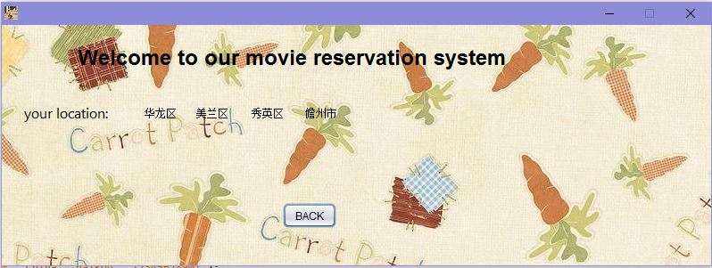

**First**

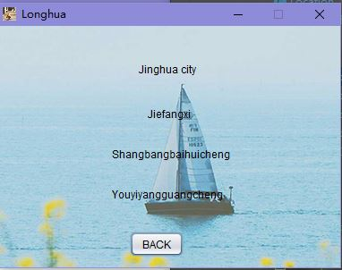

package com.all;

import java.awt.*;

import java.awt.event.*;

import javax.swing.*;

/**

* @author Spring

*/

public class First extends JFrame {

public First() {

initComponents();

}

private void jinghuacityMouseClicked(MouseEvent e) {

Seat st = new Seat();

st.setVisible(true);

dispose();

}

private void label2MouseClicked(MouseEvent e) {

Seat st = new Seat();

st.setVisible(true);

dispose();

}

private void label3MouseClicked(MouseEvent e) {

Seat st = new Seat();

st.setVisible(true);

dispose();

}

private void label4MouseClicked(MouseEvent e) {

Seat st = new Seat();

st.setVisible(true);

dispose();

}

private void button1MouseClicked(MouseEvent e) {

Location l = new Location();

l.setVisible(true);

dispose();

}

private void initComponents() {

// JFormDesigner - Component initialization - DO NOT MODIFY //GEN-BEGIN:initComponents

label5 = new JLabel();

label1 = new JLabel();

label2 = new JLabel();

label4 = new JLabel();

label3 = new JLabel();

button1 = new JButton();

label6 = new JLabel();

//======== this ========

setTitle("Longhua");

setIconImage(new ImageIcon(getClass().getResource("/Pictures/hand.jpg")).getImage());

setResizable(false);

Container contentPane = getContentPane();

contentPane.setLayout(null);

contentPane.add(label5);

label5.setBounds(new Rectangle(new Point(25, 155), label5.getPreferredSize()));

//---- label1 ----

label1.setText("Jinghua city");

label1.addMouseListener(new MouseAdapter() {

@Override

public void mouseClicked(MouseEvent e) {

jinghuacityMouseClicked(e);

}

});

contentPane.add(label1);

label1.setBounds(155, 40, 75, label1.getPreferredSize().height);

//---- label2 ----

label2.setText("Jiefangxi");

label2.addMouseListener(new MouseAdapter() {

@Override

public void mouseClicked(MouseEvent e) {

label2MouseClicked(e);

}

});

contentPane.add(label2);

label2.setBounds(165, 90, 55, label2.getPreferredSize().height);

//---- label4 ----

label4.setText("Youyiyangguangcheng");

label4.addMouseListener(new MouseAdapter() {

@Override

public void mouseClicked(MouseEvent e) {

label4MouseClicked(e);

}

});

contentPane.add(label4);

label4.setBounds(new Rectangle(new Point(125, 180), label4.getPreferredSize()));

//---- label3 ----

label3.setText("Shangbangbaihuicheng");

label3.addMouseListener(new MouseAdapter() {

@Override

public void mouseClicked(MouseEvent e) {

label3MouseClicked(e);

}

});

contentPane.add(label3);

label3.setBounds(125, 135, 140, label3.getPreferredSize().height);

//---- button1 ----

button1.setText("BACK");

button1.addMouseListener(new MouseAdapter() {

@Override

public void mouseClicked(MouseEvent e) {

button1MouseClicked(e);

}

});

contentPane.add(button1);

button1.setBounds(new Rectangle(new Point(145, 230), button1.getPreferredSize()));

//---- label6 ----

label6.setIcon(new ImageIcon(getClass().getResource("/Pictures/10.png")));

contentPane.add(label6);

label6.setBounds(0, 0, 380, 270);

{ // compute preferred size

Dimension preferredSize = new Dimension();

for(int i = 0; i < contentPane.getComponentCount(); i++) {

Rectangle bounds = contentPane.getComponent(i).getBounds();

preferredSize.width = Math.max(bounds.x + bounds.width, preferredSize.width);

preferredSize.height = Math.max(bounds.y + bounds.height, preferredSize.height);

}

Insets insets = contentPane.getInsets();

preferredSize.width += insets.right;

preferredSize.height += insets.bottom;

contentPane.setMinimumSize(preferredSize);

contentPane.setPreferredSize(preferredSize);

}

pack();

setLocationRelativeTo(getOwner());

// JFormDesigner - End of component initialization //GEN-END:initComponents

}

// JFormDesigner - Variables declaration - DO NOT MODIFY //GEN-BEGIN:variables

private JLabel label5;

private JLabel label1;

private JLabel label2;

private JLabel label4;

private JLabel label3;

private JButton button1;

private JLabel label6;

// JFormDesigner - End of variables declaration //GEN-END:variables

}

**Second**

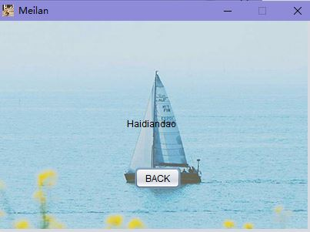

/*

* Created by JFormDesigner on Thu May 16 01:50:56 CST 2019

*/

package com.all;

import java.awt.*;

import java.awt.event.*;

import javax.swing.*;

/**

* @author Spring

*/

public class Second extends JFrame {

public Second() {

initComponents();

}

private void label1MouseClicked(MouseEvent e) {

Seat se =new Seat();

se.setVisible(true);

dispose();

}

private void button1MouseClicked(MouseEvent e) {

Location l = new Location();

l.setVisible(true);

dispose();

}

private void initComponents() {

// JFormDesigner - Component initialization - DO NOT MODIFY //GEN-BEGIN:initComponents

label1 = new JLabel();

button1 = new JButton();

label3 = new JLabel();

//======== this ========

setTitle("Meilan");

setIconImage(new ImageIcon(getClass().getResource("/Pictures/hand.jpg")).getImage());

setResizable(false);

Container contentPane = getContentPane();

contentPane.setLayout(null);

//---- label1 ----

label1.setText("Haidiandao");

label1.addMouseListener(new MouseAdapter() {

@Override

public void mouseClicked(MouseEvent e) {

label1MouseClicked(e);

}

});

contentPane.add(label1);

label1.setBounds(new Rectangle(new Point(165, 125), label1.getPreferredSize()));

//---- button1 ----

button1.setText("BACK");

button1.addMouseListener(new MouseAdapter() {

@Override

public void mouseClicked(MouseEvent e) {

button1MouseClicked(e);

}

});

contentPane.add(button1);

button1.setBounds(new Rectangle(new Point(175, 190), button1.getPreferredSize()));

//---- label3 ----

label3.setIcon(new ImageIcon(getClass().getResource("/Pictures/10.png")));

contentPane.add(label3);

label3.setBounds(0, 0, 400, 270);

{ // compute preferred size

Dimension preferredSize = new Dimension();

for(int i = 0; i < contentPane.getComponentCount(); i++) {

Rectangle bounds = contentPane.getComponent(i).getBounds();

preferredSize.width = Math.max(bounds.x + bounds.width, preferredSize.width);

preferredSize.height = Math.max(bounds.y + bounds.height, preferredSize.height);

}

Insets insets = contentPane.getInsets();

preferredSize.width += insets.right;

preferredSize.height += insets.bottom;

contentPane.setMinimumSize(preferredSize);

contentPane.setPreferredSize(preferredSize);

}

pack();

setLocationRelativeTo(getOwner());

// JFormDesigner - End of component initialization //GEN-END:initComponents

}

// JFormDesigner - Variables declaration - DO NOT MODIFY //GEN-BEGIN:variables

private JLabel label1;

private JButton button1;

private JLabel label3;

// JFormDesigner - End of variables declaration //GEN-END:variables

}

**Third**

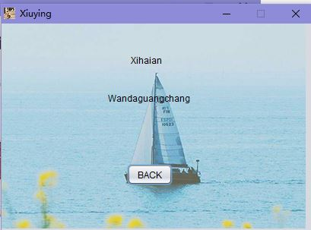

/*

* Created by JFormDesigner on Thu May 16 01:51:12 CST 2019

*/

package com.all;

import java.awt.*;

import java.awt.event.*;

import javax.swing.*;

/**

* @author Spring

*/

public class Third extends JFrame {

public Third() {

initComponents();

}

private void label1MouseClicked(MouseEvent e) {

Seat se =new Seat();

se.setVisible(true);

dispose();

}

private void label2MouseClicked(MouseEvent e) {

Seat se =new Seat();

se.setVisible(true);

dispose();

}

private void button1MouseClicked(MouseEvent e) {

Location l = new Location();

l.setVisible(true);

dispose();

}

private void initComponents() {

// JFormDesigner - Component initialization - DO NOT MODIFY //GEN-BEGIN:initComponents

label1 = new JLabel();

label2 = new JLabel();

button1 = new JButton();

label3 = new JLabel();

//======== this ========

setTitle("Xiuying");

setIconImage(new ImageIcon(getClass().getResource("/Pictures/hand.jpg")).getImage());

setResizable(false);

Container contentPane = getContentPane();

contentPane.setLayout(null);

//---- label1 ----

label1.setText("Xihaian");

label1.addMouseListener(new MouseAdapter() {

@Override

public void mouseClicked(MouseEvent e) {

label1MouseClicked(e);

}

});

contentPane.add(label1);

label1.setBounds(new Rectangle(new Point(170, 40), label1.getPreferredSize()));

//---- label2 ----

label2.setText("Wandaguangchang");

label2.addMouseListener(new MouseAdapter() {

@Override

public void mouseClicked(MouseEvent e) {

label2MouseClicked(e);

}

});

contentPane.add(label2);

label2.setBounds(new Rectangle(new Point(140, 90), label2.getPreferredSize()));

//---- button1 ----

button1.setText("BACK");

button1.addMouseListener(new MouseAdapter() {

@Override

public void mouseClicked(MouseEvent e) {

button1MouseClicked(e);

}

});

contentPane.add(button1);

button1.setBounds(new Rectangle(new Point(165, 185), button1.getPreferredSize()));

//---- label3 ----

label3.setIcon(new ImageIcon(getClass().getResource("/Pictures/10.png")));

contentPane.add(label3);

label3.setBounds(0, 0, 400, 270);

{ // compute preferred size

Dimension preferredSize = new Dimension();

for(int i = 0; i < contentPane.getComponentCount(); i++) {

Rectangle bounds = contentPane.getComponent(i).getBounds();

preferredSize.width = Math.max(bounds.x + bounds.width, preferredSize.width);

preferredSize.height = Math.max(bounds.y + bounds.height, preferredSize.height);

}

Insets insets = contentPane.getInsets();

preferredSize.width += insets.right;

preferredSize.height += insets.bottom;

contentPane.setMinimumSize(preferredSize);

contentPane.setPreferredSize(preferredSize);

}

pack();

setLocationRelativeTo(getOwner());

// JFormDesigner - End of component initialization //GEN-END:initComponents

}

// JFormDesigner - Variables declaration - DO NOT MODIFY //GEN-BEGIN:variables

private JLabel label1;

private JLabel label2;

private JButton button1;

private JLabel label3;

// JFormDesigner - End of variables declaration //GEN-END:variables

}

**Fourth**

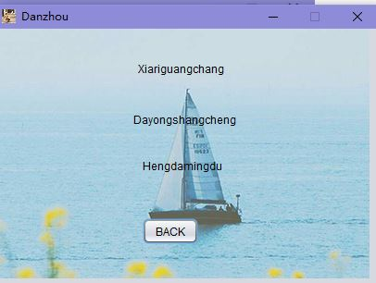

/*

* Created by JFormDesigner on Thu May 16 01:51:38 CST 2019

*/

package com.all;

import java.awt.*;

import java.awt.event.*;

import javax.swing.*;

/**

* @author Spring

*/

public class Fourth extends JFrame {

public Fourth() {

initComponents();

}

private void label1MouseClicked(MouseEvent e) {

Seat se =new Seat();

se.setVisible(true);

dispose();

}

private void label2MouseClicked(MouseEvent e) {

Seat se =new Seat();

se.setVisible(true);

dispose();

}

private void label3MouseClicked(MouseEvent e) {

Seat se =new Seat();

se.setVisible(true);

dispose();

}

private void BACKMouseClicked(MouseEvent e) {

Show s =new Show();

s.setVisible(true);

dispose();

}

private void initComponents() {

// JFormDesigner - Component initialization - DO NOT MODIFY //GEN-BEGIN:initComponents

label1 = new JLabel();

label2 = new JLabel();

label3 = new JLabel();

button1 = new JButton();

label4 = new JLabel();

//======== this ========

setTitle("Danzhou");

setIconImage(new ImageIcon(getClass().getResource("/Pictures/hand.jpg")).getImage());

setResizable(false);

Container contentPane = getContentPane();

contentPane.setLayout(null);

//---- label1 ----

label1.setText("Xiariguangchang");

label1.addMouseListener(new MouseAdapter() {

@Override

public void mouseClicked(MouseEvent e) {

label1MouseClicked(e);

}

});

contentPane.add(label1);

label1.setBounds(new Rectangle(new Point(150, 35), label1.getPreferredSize()));

//---- label2 ----

label2.setText("Dayongshangcheng");

label2.addMouseListener(new MouseAdapter() {

@Override

public void mouseClicked(MouseEvent e) {

label2MouseClicked(e);

}

});

contentPane.add(label2);

label2.setBounds(new Rectangle(new Point(145, 90), label2.getPreferredSize()));

//---- label3 ----

label3.setText("Hengdamingdu");

label3.addMouseListener(new MouseAdapter() {

@Override

public void mouseClicked(MouseEvent e) {

label3MouseClicked(e);

}

});

contentPane.add(label3);

label3.setBounds(new Rectangle(new Point(155, 140), label3.getPreferredSize()));

//---- button1 ----

button1.setText("BACK");

button1.addMouseListener(new MouseAdapter() {

@Override

public void mouseClicked(MouseEvent e) {

BACKMouseClicked(e);

}

});

contentPane.add(button1);

button1.setBounds(new Rectangle(new Point(155, 205), button1.getPreferredSize()));

//---- label4 ----

label4.setIcon(new ImageIcon(getClass().getResource("/Pictures/10.png")));

contentPane.add(label4);

label4.setBounds(0, 0, 400, 270);

{ // compute preferred size

Dimension preferredSize = new Dimension();

for(int i = 0; i < contentPane.getComponentCount(); i++) {

Rectangle bounds = contentPane.getComponent(i).getBounds();

preferredSize.width = Math.max(bounds.x + bounds.width, preferredSize.width);

preferredSize.height = Math.max(bounds.y + bounds.height, preferredSize.height);

}

Insets insets = contentPane.getInsets();

preferredSize.width += insets.right;

preferredSize.height += insets.bottom;

contentPane.setMinimumSize(preferredSize);

contentPane.setPreferredSize(preferredSize);

}

pack();

setLocationRelativeTo(getOwner());

// JFormDesigner - End of component initialization //GEN-END:initComponents

}

// JFormDesigner - Variables declaration - DO NOT MODIFY //GEN-BEGIN:variables

private JLabel label1;

private JLabel label2;

private JLabel label3;

private JButton button1;

private JLabel label4;

// JFormDesigner - End of variables declaration //GEN-END:variables

}

**Code of Chose a seat**

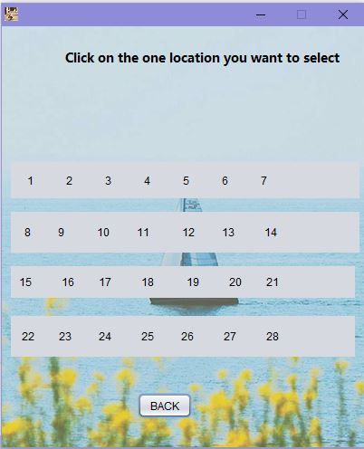

/*

* Created by JFormDesigner on Thu May 16 11:14:31 CST 2019

*/

package com.all;

import java.awt.*;

import java.awt.event.*;

import javax.swing.*;

/**

* @author BORBER

*/

public class Seat extends JFrame {

public Seat() {

initComponents();

}

private void label1MouseClicked(MouseEvent e) {

JOptionPane.showMessageDialog(null,"你成功订购了1号座位" );

}

private void label2MouseClicked(MouseEvent e) {

JOptionPane.showMessageDialog(null,"你成功订购了2号座位" );

}

private void label3MouseClicked(MouseEvent e) {

JOptionPane.showMessageDialog(null,"你成功订购了3号座位" );

}

private void label4MouseClicked(MouseEvent e) {

JOptionPane.showMessageDialog(null,"你成功订购了4号座位" );

}

private void label5MouseClicked(MouseEvent e) {

JOptionPane.showMessageDialog(null,"你成功订购了5号座位" );

}

private void label6MouseClicked(MouseEvent e) {

JOptionPane.showMessageDialog(null,"你成功订购了6号座位" );

}

private void label7MouseClicked(MouseEvent e) {

JOptionPane.showMessageDialog(null,"你成功订购了7号座位" );

}

private void label8MouseClicked(MouseEvent e) {

JOptionPane.showMessageDialog(null,"你成功订购了8号座位" );

}

private void label9MouseClicked(MouseEvent e) {

JOptionPane.showMessageDialog(null,"你成功订购了9号座位" );

}

private void label10MouseClicked(MouseEvent e) {

JOptionPane.showMessageDialog(null,"你成功订购了10号座位" );

}

private void label11MouseClicked(MouseEvent e) {

JOptionPane.showMessageDialog(null,"你成功订购了11号座位" );

}

private void label12MouseClicked(MouseEvent e) {

JOptionPane.showMessageDialog(null,"你成功订购了12号座位" );

}

private void label13MouseClicked(MouseEvent e) {

JOptionPane.showMessageDialog(null,"你成功订购了13号座位" );

}

private void label14MouseClicked(MouseEvent e) {

JOptionPane.showMessageDialog(null,"你成功订购了14号座位" );

}

private void label15MouseClicked(MouseEvent e) {

JOptionPane.showMessageDialog(null,"你成功订购了15号座位" );

}

private void label16MouseClicked(MouseEvent e) {

JOptionPane.showMessageDialog(null,"你成功订购了16号座位" );

}

private void label17MouseClicked(MouseEvent e) {

JOptionPane.showMessageDialog(null,"你成功订购了17号座位" );

}

private void label18MouseClicked(MouseEvent e) {

JOptionPane.showMessageDialog(null,"你成功订购了18号座位" );

}

private void label19MouseClicked(MouseEvent e) {

JOptionPane.showMessageDialog(null,"你成功订购了19号座位" );

}

private void label20MouseClicked(MouseEvent e) {

JOptionPane.showMessageDialog(null,"你成功订购了20号座位" );

}

private void label21MouseClicked(MouseEvent e) {

JOptionPane.showMessageDialog(null,"你成功订购了21号座位" );

}

private void label22MouseClicked(MouseEvent e) {

JOptionPane.showMessageDialog(null,"你成功订购了22号座位" );

}

private void label23MouseClicked(MouseEvent e) {

JOptionPane.showMessageDialog(null,"你成功订购了23号座位" );

}

private void label24MouseClicked(MouseEvent e) {

JOptionPane.showMessageDialog(null,"你成功订购了24号座位" );

}

private void label25MouseClicked(MouseEvent e) {

JOptionPane.showMessageDialog(null,"你成功订购了25号座位" );

}

private void label26MouseClicked(MouseEvent e) {

JOptionPane.showMessageDialog(null,"你成功订购了26号座位" );

}

private void label27MouseClicked(MouseEvent e) {

JOptionPane.showMessageDialog(null,"你成功订购了27号座位" );

}

private void label28MouseClicked(MouseEvent e) {

JOptionPane.showMessageDialog(null,"你成功订购了28号座位" );

}

private void OKMouseClicked(MouseEvent e) {

Location l = new Location();

l.setVisible(true);

dispose();

}

private void initComponents() {

// JFormDesigner - Component initialization - DO NOT MODIFY //GEN-BEGIN:initComponents

panel2 = new JPanel();

label15 = new JLabel();

label16 = new JLabel();

label17 = new JLabel();

label18 = new JLabel();

label19 = new JLabel();

label20 = new JLabel();

label21 = new JLabel();

panel3 = new JPanel();

label8 = new JLabel();

label9 = new JLabel();

label10 = new JLabel();

label11 = new JLabel();

label12 = new JLabel();

label13 = new JLabel();

label14 = new JLabel();

panel4 = new JPanel();

label22 = new JLabel();

label23 = new JLabel();

label24 = new JLabel();

label25 = new JLabel();

label26 = new JLabel();

label27 = new JLabel();

label28 = new JLabel();

label29 = new JLabel();

button1 = new JButton();

panel5 = new JPanel();

label1 = new JLabel();

label2 = new JLabel();

lable3 = new JLabel();

label4 = new JLabel();

label5 = new JLabel();

label6 = new JLabel();

label7 = new JLabel();

label30 = new JLabel();

//======== this ========

setIconImage(new ImageIcon(getClass().getResource("/Pictures/hand.jpg")).getImage());

setResizable(false);

Container contentPane = getContentPane();

contentPane.setLayout(null);

//======== panel2 ========

{

panel2.setLayout(new BoxLayout(panel2, BoxLayout.X_AXIS));

//---- label15 ----

label15.setText(" 15 ");

label15.addMouseListener(new MouseAdapter() {

@Override

public void mouseClicked(MouseEvent e) {

label15MouseClicked(e);

}

});

panel2.add(label15);

//---- label16 ----

label16.setText(" 16 ");

label16.addMouseListener(new MouseAdapter() {

@Override

public void mouseClicked(MouseEvent e) {

label16MouseClicked(e);

}

});

panel2.add(label16);

//---- label17 ----

label17.setText(" 17 ");

label17.addMouseListener(new MouseAdapter() {

@Override

public void mouseClicked(MouseEvent e) {

label17MouseClicked(e);

}

});

panel2.add(label17);

//---- label18 ----

label18.setText(" 18 ");

label18.addMouseListener(new MouseAdapter() {

@Override

public void mouseClicked(MouseEvent e) {

label18MouseClicked(e);

}

});

panel2.add(label18);

//---- label19 ----

label19.setText(" 19 ");

label19.addMouseListener(new MouseAdapter() {

@Override

public void mouseClicked(MouseEvent e) {

label19MouseClicked(e);

}

});

panel2.add(label19);

//---- label20 ----

label20.setText(" 20 ");

label20.addMouseListener(new MouseAdapter() {

@Override

public void mouseClicked(MouseEvent e) {

label20MouseClicked(e);

}

});

panel2.add(label20);

//---- label21 ----

label21.setText(" 21 ");

label21.addMouseListener(new MouseAdapter() {

@Override

public void mouseClicked(MouseEvent e) {

label21MouseClicked(e);

}

});

panel2.add(label21);

}

contentPane.add(panel2);

panel2.setBounds(10, 265, 380, 35);

//======== panel3 ========

{

panel3.setLayout(new BoxLayout(panel3, BoxLayout.X_AXIS));

//---- label8 ----

label8.setText(" 8 ");

label8.addMouseListener(new MouseAdapter() {

@Override

public void mouseClicked(MouseEvent e) {

label8MouseClicked(e);

label8MouseClicked(e);

}

});

panel3.add(label8);

//---- label9 ----

label9.setText(" 9 ");

label9.addMouseListener(new MouseAdapter() {

@Override

public void mouseClicked(MouseEvent e) {

label9MouseClicked(e);

}

});

panel3.add(label9);

//---- label10 ----

label10.setText(" 10 ");

label10.addMouseListener(new MouseAdapter() {

@Override

public void mouseClicked(MouseEvent e) {

label10MouseClicked(e);

}

});

panel3.add(label10);

//---- label11 ----

label11.setText(" 11 ");

label11.addMouseListener(new MouseAdapter() {

@Override

public void mouseClicked(MouseEvent e) {

label11MouseClicked(e);

}

});

panel3.add(label11);

//---- label12 ----

label12.setText(" 12 ");

label12.addMouseListener(new MouseAdapter() {

@Override

public void mouseClicked(MouseEvent e) {

label12MouseClicked(e);

}

});

panel3.add(label12);

//---- label13 ----

label13.setText(" 13 ");

label13.addMouseListener(new MouseAdapter() {

@Override

public void mouseClicked(MouseEvent e) {

label13MouseClicked(e);

}

});

panel3.add(label13);

//---- label14 ----

label14.setText(" 14 ");

label14.addMouseListener(new MouseAdapter() {

@Override

public void mouseClicked(MouseEvent e) {

label14MouseClicked(e);

}

});

panel3.add(label14);

}

contentPane.add(panel3);

panel3.setBounds(10, 205, 385, 45);

//======== panel4 ========

{

panel4.setLayout(new BoxLayout(panel4, BoxLayout.X_AXIS));

//---- label22 ----

label22.setText(" 22 ");

label22.addMouseListener(new MouseAdapter() {

@Override

public void mouseClicked(MouseEvent e) {

label22MouseClicked(e);

}

});

panel4.add(label22);

//---- label23 ----

label23.setText(" 23 ");

label23.addMouseListener(new MouseAdapter() {

@Override

public void mouseClicked(MouseEvent e) {

label23MouseClicked(e);

}

});

panel4.add(label23);

//---- label24 ----

label24.setText(" 24 ");

label24.addMouseListener(new MouseAdapter() {

@Override

public void mouseClicked(MouseEvent e) {

label24MouseClicked(e);

}

});

panel4.add(label24);

//---- label25 ----

label25.setText(" 25 ");

label25.addMouseListener(new MouseAdapter() {

@Override

public void mouseClicked(MouseEvent e) {

label25MouseClicked(e);

}

});

panel4.add(label25);

//---- label26 ----

label26.setText(" 26 ");

label26.addMouseListener(new MouseAdapter() {

@Override

public void mouseClicked(MouseEvent e) {

label26MouseClicked(e);

}

});

panel4.add(label26);

//---- label27 ----

label27.setText(" 27 ");

label27.addMouseListener(new MouseAdapter() {

@Override

public void mouseClicked(MouseEvent e) {

label27MouseClicked(e);

}

});

panel4.add(label27);

//---- label28 ----

label28.setText(" 28 ");

label28.addMouseListener(new MouseAdapter() {

@Override

public void mouseClicked(MouseEvent e) {

label28MouseClicked(e);

}

});

panel4.add(label28);

}

contentPane.add(panel4);

panel4.setBounds(10, 320, 380, 45);

//---- label29 ----

label29.setText("Click on the one location you want to select");

label29.setFont(new Font("Microsoft YaHei UI", Font.BOLD, 14));

contentPane.add(label29);

label29.setBounds(new Rectangle(new Point(70, 25), label29.getPreferredSize()));

//---- button1 ----

button1.setText("BACK");

button1.addMouseListener(new MouseAdapter() {

@Override

public void mouseClicked(MouseEvent e) {

OKMouseClicked(e);

}

});

contentPane.add(button1);

button1.setBounds(new Rectangle(new Point(150, 405), button1.getPreferredSize()));

//======== panel5 ========

{

panel5.setLayout(new BoxLayout(panel5, BoxLayout.X_AXIS));

//---- label1 ----

label1.setText(" 1 ");

label1.addMouseListener(new MouseAdapter() {

@Override

public void mouseClicked(MouseEvent e) {

label1MouseClicked(e);

}

});

panel5.add(label1);

//---- label2 ----

label2.setText(" 2 ");

label2.addMouseListener(new MouseAdapter() {

@Override

public void mouseClicked(MouseEvent e) {

label2MouseClicked(e);

}

});

panel5.add(label2);

//---- lable3 ----

lable3.setText(" 3 ");

lable3.addMouseListener(new MouseAdapter() {

@Override

public void mouseClicked(MouseEvent e) {

label3MouseClicked(e);

}

});

panel5.add(lable3);

//---- label4 ----

label4.setText(" 4 ");

label4.addMouseListener(new MouseAdapter() {

@Override

public void mouseClicked(MouseEvent e) {

label4MouseClicked(e);

}

});

panel5.add(label4);

//---- label5 ----

label5.setText(" 5 ");

label5.addMouseListener(new MouseAdapter() {

@Override

public void mouseClicked(MouseEvent e) {

label5MouseClicked(e);

}

});

panel5.add(label5);

//---- label6 ----

label6.setText(" 6 ");

label6.addMouseListener(new MouseAdapter() {

@Override

public void mouseClicked(MouseEvent e) {

label6MouseClicked(e);

}

});

panel5.add(label6);

//---- label7 ----

label7.setText(" 7 ");

label7.addMouseListener(new MouseAdapter() {

@Override

public void mouseClicked(MouseEvent e) {

label7MouseClicked(e);

}

});

panel5.add(label7);

}

contentPane.add(panel5);

panel5.setBounds(10, 150, 385, 40);

//---- label30 ----

label30.setIcon(new ImageIcon(getClass().getResource("/Pictures/10.png")));

contentPane.add(label30);

label30.setBounds(0, 0, 400, 465);

{ // compute preferred size

Dimension preferredSize = new Dimension();

for(int i = 0; i < contentPane.getComponentCount(); i++) {

Rectangle bounds = contentPane.getComponent(i).getBounds();

preferredSize.width = Math.max(bounds.x + bounds.width, preferredSize.width);

preferredSize.height = Math.max(bounds.y + bounds.height, preferredSize.height);

}

Insets insets = contentPane.getInsets();

preferredSize.width += insets.right;

preferredSize.height += insets.bottom;

contentPane.setMinimumSize(preferredSize);

contentPane.setPreferredSize(preferredSize);

}

pack();

setLocationRelativeTo(getOwner());

// JFormDesigner - End of component initialization //GEN-END:initComponents

}

// JFormDesigner - Variables declaration - DO NOT MODIFY //GEN-BEGIN:variables

private JPanel panel2;

private JLabel label15;

private JLabel label16;

private JLabel label17;

private JLabel label18;

private JLabel label19;

private JLabel label20;

private JLabel label21;

private JPanel panel3;

private JLabel label8;

private JLabel label9;

private JLabel label10;

private JLabel label11;

private JLabel label12;

private JLabel label13;

private JLabel label14;

private JPanel panel4;

private JLabel label22;

private JLabel label23;

private JLabel label24;

private JLabel label25;

private JLabel label26;

private JLabel label27;

private JLabel label28;

private JLabel label29;

private JButton button1;

private JPanel panel5;

private JLabel label1;

private JLabel label2;

private JLabel lable3;

private JLabel label4;

private JLabel label5;

private JLabel label6;

private JLabel label7;

private JLabel label30;

// JFormDesigner - End of variables declaration //GEN-END:variables

}

**Code of Connect_SQL**

package com.company;

import java.sql.Connection;

import java.sql.DriverManager;

import java.sql.SQLException;

import static com.all.conString.*;

public class connectSQL {

private Connection SJ = null;

public Connection conSql(){

try {

Class.forName(mysqlClass);

SJ = DriverManager.getConnection(mysqlURL, mysqlName, mysqlPass);

if(SJ != null){

System.out.println("链接成功");

}

} catch (ClassNotFoundException e) {

System.out.println("类不存在");

} catch (SQLException e) {

System.out.println("连接错误");

}

return SJ;

}

}

**Code of For_SQL**

package com.company;

import java.sql.Connection;

import java.sql.PreparedStatement;

public class For_SQL {

public static PreparedStatement PST = null;

public static Connection CONN = null;

}

**Code of registerSQL**

package com.all;

import com.company.connectSQL;

import java.sql.Connection;

import java.sql.PreparedStatement;

import java.sql.ResultSet;

import java.sql.SQLException;

import static com.all.conString.*;

public class registerSQL {

public registerSQL(String name,String password,String sex,String email){

this.name = name;

this.password = password;

this.sex = sex;

this.email = email;

}

public void registerUser(){

try{

CON = new connectSQL().conSql();

PST = CON.prepareStatement(nameDiff);

PST.setString(1,name);

RS = PST.executeQuery();

if(RS.next()){

new Loss();

return;

}

PST = CON.prepareStatement(getIDSQL);

RS = PST.executeQuery();

if(RS.next()){

addID =RS.getInt(1) + 1;

}

PST = CON.prepareStatement(addUser);

PST.setInt(1,addID);

PST.setString(2,name);

PST.setString(3,password);

PST.setString(4,sex);

PST.setString(5,email);

PST.executeUpdate();

PST = CON.prepareStatement(loginSQL);

PST.setString(1,name);

PST.setString(2,password);

RS = PST.executeQuery();

if(RS.next()){

new Win();

}

} catch (SQLException e) {

e.printStackTrace();

}

}

int addID = 0;

int ID = 0;

String name;

String password;

String sex;

String email;

Connection CON = null;

PreparedStatement PST = null;

ResultSet RS = null;

}

**Code of JTextFileLimit**

package com.all;

import javax.swing.text.AttributeSet;

import javax.swing.text.BadLocationException;

import javax.swing.text.PlainDocument;

public class JTextFieldLimit extends PlainDocument {

private int limit;

public JTextFieldLimit(int limit){

super();

this.limit = limit;

}

JTextFieldLimit(int limit,boolean upper){

super();

this.limit=limit;

}

@Override

public void insertString(int offset, String str, AttributeSet attr)throws BadLocationException{

if(str == null){

return;

}

if((getLength()+str.length()) <= limit)

super.insertString(offset,str,attr);

}

}

**Code of other**

package com.all;

import java.awt.*;

import java.awt.event.*;

import javax.swing.*;

public class Win extends JFrame {

public Win() {

initComponents();

}

private void LoginMouseClicked(MouseEvent e) {

new Registered_login().setVisible(true);

}

private void initComponents() {

// JFormDesigner - Component initialization - DO NOT MODIFY //GEN-BEGIN:initComponents

label1 = new JLabel();

button1 = new JButton();

//======== this ========

setResizable(false);

Container contentPane = getContentPane();

contentPane.setLayout(null);

//---- label1 ----

label1.setText("\u6ce8\u518c\u6210\u529f");

contentPane.add(label1);

label1.setBounds(new Rectangle(new Point(115, 65), label1.getPreferredSize()));

//---- button1 ----

button1.setText("Login");

button1.addMouseListener(new MouseAdapter() {

@Override

public void mouseClicked(MouseEvent e) {

LoginMouseClicked(e);

}

});

contentPane.add(button1);

button1.setBounds(new Rectangle(new Point(105, 140), button1.getPreferredSize()));

{ // compute preferred size

Dimension preferredSize = new Dimension();

for(int i = 0; i < contentPane.getComponentCount(); i++) {

Rectangle bounds = contentPane.getComponent(i).getBounds();

preferredSize.width = Math.max(bounds.x + bounds.width, preferredSize.width);

preferredSize.height = Math.max(bounds.y + bounds.height, preferredSize.height);

}

Insets insets = contentPane.getInsets();

preferredSize.width += insets.right;

preferredSize.height += insets.bottom;

contentPane.setMinimumSize(preferredSize);

contentPane.setPreferredSize(preferredSize);

}

pack();

setLocationRelativeTo(getOwner());

// JFormDesigner - End of component initialization //GEN-END:initComponents

}

// JFormDesigner - Variables declaration - DO NOT MODIFY //GEN-BEGIN:variables

private JLabel label1;

private JButton button1;

// JFormDesigner - End of variables declaration //GEN-END:variables

}

package com.all;

import java.awt.*;

import java.awt.event.*;

import javax.swing.*;

public class Loss extends JFrame {

public Loss() {

initComponents();

}

private void button1MouseClicked(MouseEvent e) {

this.dispose();

}

private void initComponents() {

// JFormDesigner - Component initialization - DO NOT MODIFY //GEN-BEGIN:initComponents

label1 = new JLabel();

button1 = new JButton();

setResizable(false);

Container contentPane = getContentPane();

contentPane.setLayout(null);

//---- label1 ----

label1.setText("\u6ce8\u518c\u5931\u8d25");

contentPane.add(label1);

label1.setBounds(new Rectangle(new Point(145, 70), label1.getPreferredSize()));

//---- button1 ----

button1.setText("Cancel");

button1.addMouseListener(new MouseAdapter() {

@Override

public void mouseClicked(MouseEvent e) {

button1MouseClicked(e);

}

});

contentPane.add(button1);

button1.setBounds(new Rectangle(new Point(130, 130), button1.getPreferredSize()));

{ // compute preferred size

Dimension preferredSize = new Dimension();

for(int i = 0; i < contentPane.getComponentCount(); i++) {

Rectangle bounds = contentPane.getComponent(i).getBounds();

preferredSize.width = Math.max(bounds.x + bounds.width, preferredSize.width);

preferredSize.height = Math.max(bounds.y + bounds.height, preferredSize.height);

}

Insets insets = contentPane.getInsets();

preferredSize.width += insets.right;

preferredSize.height += insets.bottom;

contentPane.setMinimumSize(preferredSize);

contentPane.setPreferredSize(preferredSize);

}

pack();

setLocationRelativeTo(getOwner());

// JFormDesigner - End of component initialization //GEN-END:initComponents

}

// JFormDesigner - Variables declaration - DO NOT MODIFY //GEN-BEGIN:variables

private JLabel label1;

private JButton button1;

// JFormDesigner - End of variables declaration //GEN-END:variables

}

**Code of conString**

package com.all;

public class conString {

public final static String loginSQL = "select * from user where name = ? and password = ?;";

public final static String adminSQL = "select * from admin where name = ? and password = ?;";

public final static String getIDSQL = "select MAX(ID) from user;";

public final static String nameDiff = "select * from user where name = ?;";

public final static String addUser = "insert into user value (?,?,?,?,?);";

public final static String mariadbName = "root";

public final static String mariadbPass = "907089";

public final static String mariadbURL = "jdbc:LoginDB://localhost:3306/testJavaConnection";

public final static String mariadbClass = "org.LoginDB.jdbc.Driver";

public final static String mysqlName = "root";

public final static String mysqlPass = "1234";

public final static String mysqlURL = "jdbc:mysql://127.0.0.1:3306/logindb";

public final static String mysqlClass = "com.mysql.jdbc.Driver";

public final static String adminSeeAll = "select * from user;";

public final static String adminSreach = "select * from user where name like ?;";

public final static String getLastTimeSQL = "select * from loginTime where ID = ? order by loginTime desc limit 1;";

public final static String addDate = "insert into loginTime value (?,?);";

}